Code Smells Identification



Clara Sousa 58403

Long Parameter List

Code Snippet:
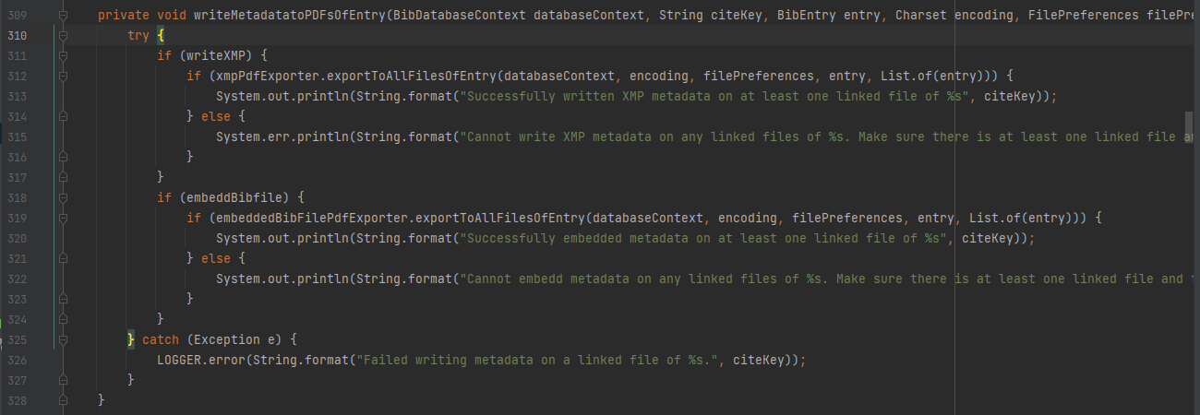
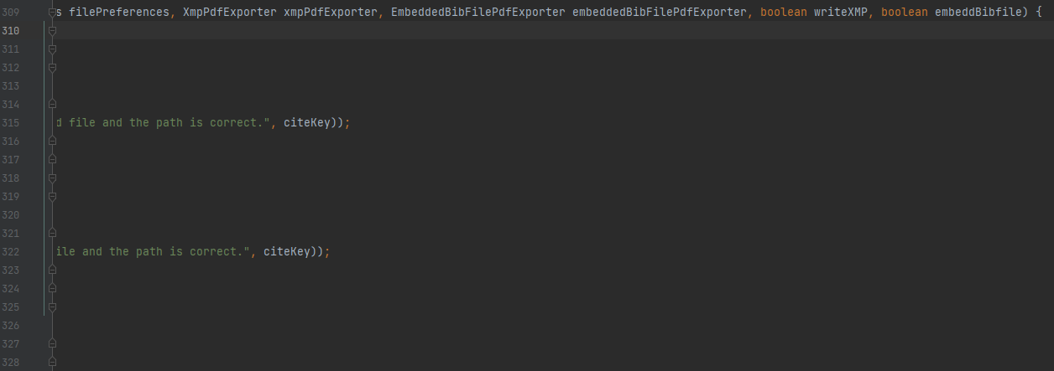

Location: src/main/java/org/jabref/cli/ArgumentProcessor.java

Explanation: A code smell of the type “Long Parameter List” is present when a certain method presents two many parameters (usually, more than 4); in this class, the method “writeMetadatatoPDFsOfEntry” has 9 parameters.

Refactoring Proposal: In order to solve this code smell, one could simply group the parameters into different types / classes, introducing new parameter objects. E.g.: have a class “Entry” that would contain the parameters databaseContext, citeKey, entry and encoding; have a class “Exporter” that would contain filePreferences, xmpPdfExporter, embeddedBibFilePdfExporter.

Data Class

Code Snippet:

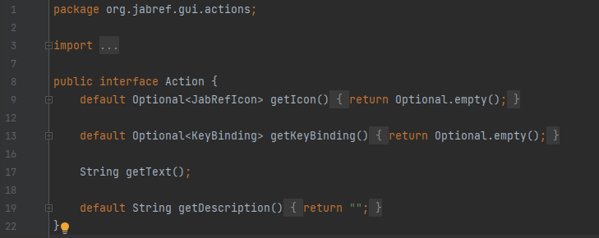

Location: src/main/java/org/jabref/gui/actions/Action.java

Explanation: “Action” is a very small classes that has no real functionality, being able to present only getter methods such as “getIcon” and “getKeyBind”. This matches the definition of the code smell called Data Class.

Refactoring Proposal: Instead of having this class, perhaps the methods in it should be placed in another, better suited class.

Shotgun Surgery

Code Snippet:

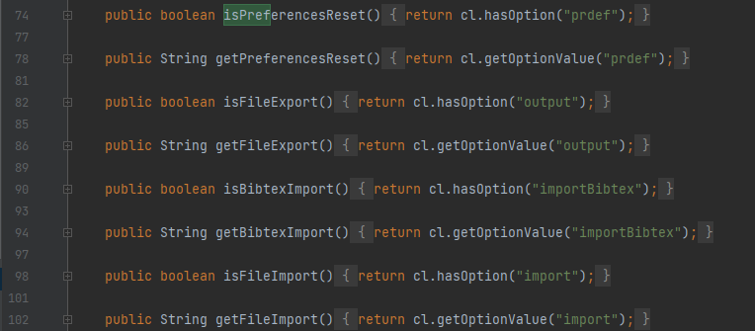
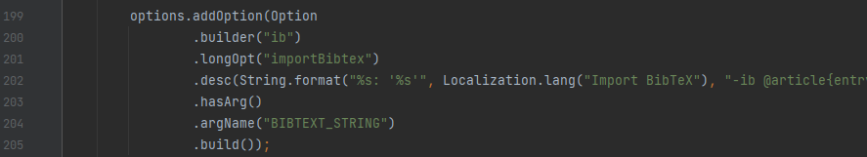
Location: src/main/java/org/jabref/cli/JabRefCLI.java

Explanation: The Shotgun Surgery occurs when, by making a change in one place, a numerous amount of classes all over the design need to be changed in order to make that one change happen. In this case, if, for example, the string “importBibtex” was to be changed, one would have to manually change all the places where it exists, throughout the class.

Refactoring Proposal: One easy way to avoid this uncessary re-writing that is so prone to inadvertently producing issues is to create constants that are then used in the methods of the class; this way, if one wishes to change the value of a string, all that must be done is to change the value of that constant.

